What is AWS?

Amazon web service is a platform that offers flexible, reliable, scalable, easy-to-use and cost-effective cloud computing solutions.

SOA (Service oriented Architecture)

Everything in chunks is available which you can use as service.

Queing

Virtual machines

Db services

Storage services

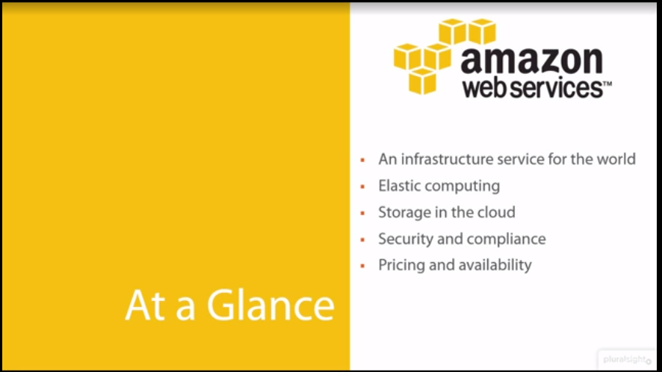

AWS is a comprehensive, easy to use computing platform offered Amazon. The platform is developed with a combination of infrastructure as a service (IaaS), platform as a service (PaaS) and packaged software as a service (SaaS) offerings.

Service model:

IaaS: Infrastructure as service

PaaS: Platform as service

SaaS: Software as service

